**Regular Expressions**

To find a word ninja :

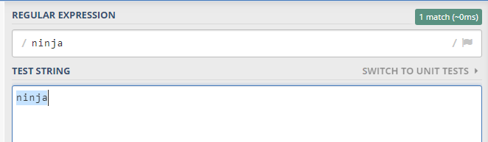

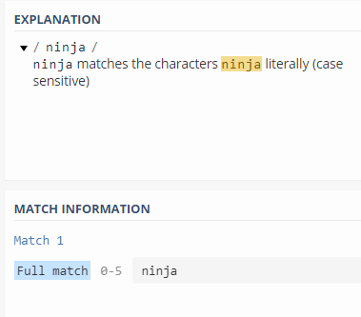

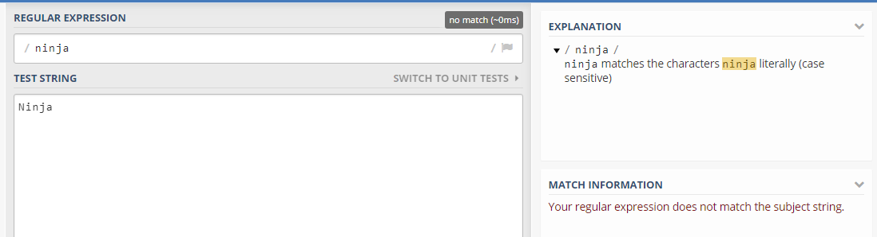

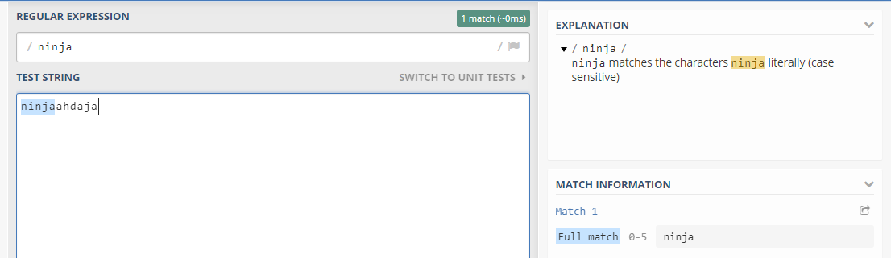

Global flag looks for every matching word

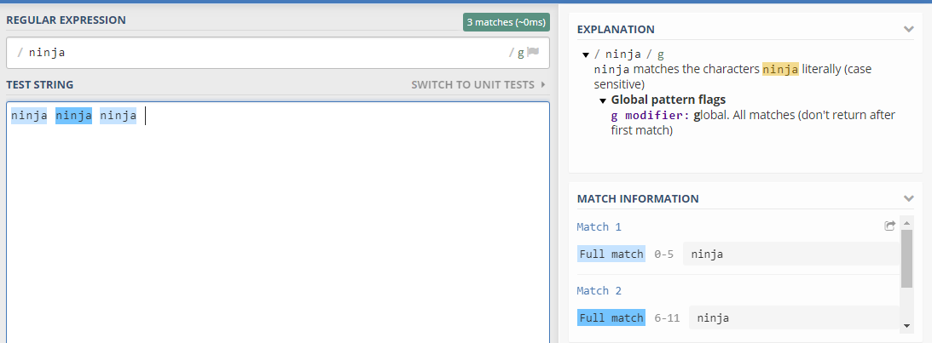

Case insensitive flag ignores case letters

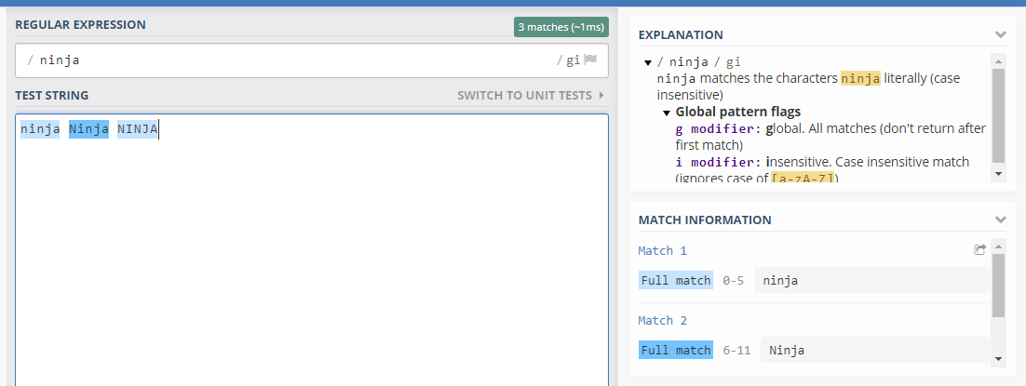

Character Sets :

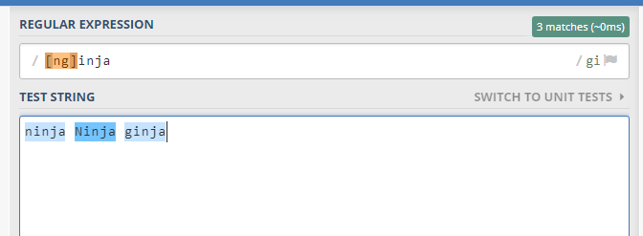

It means first letter can either be n or g

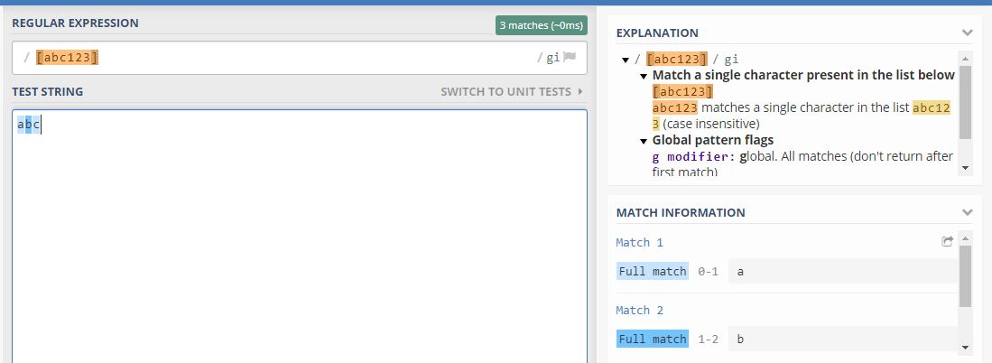

[ ] means first position

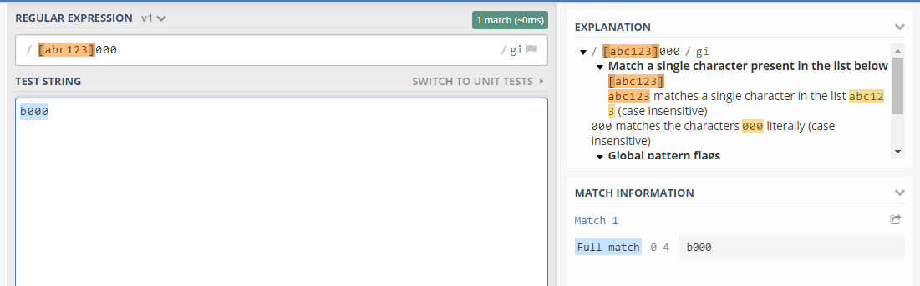

**Exclude SET :**

Anything else will match expect the ones in set.

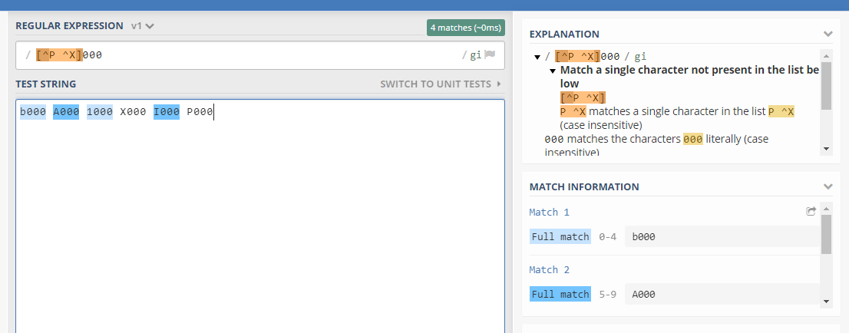

**Ranges :**

First letter can be any in the range given outside the range is excluded.

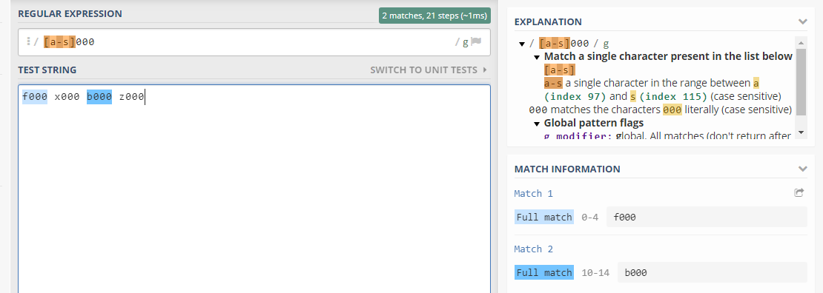

For both upper and lower cases :

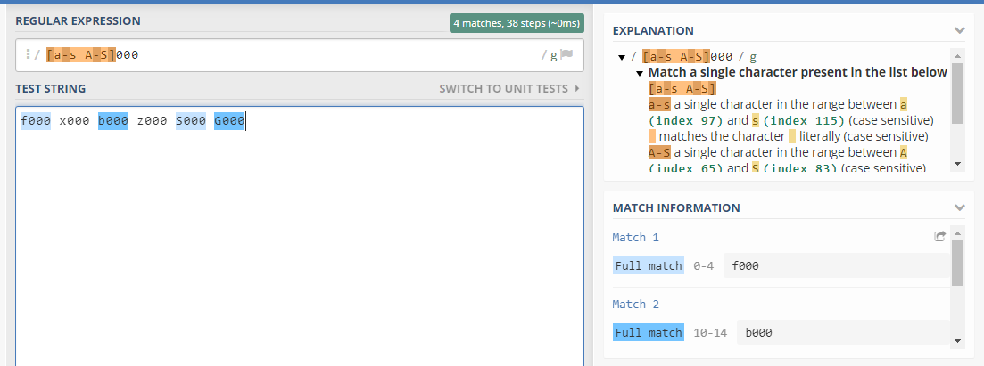

**Repeating Characters :**

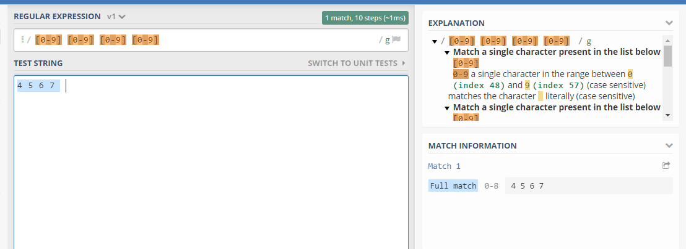

SO u don’t have to write [0-9] many times.

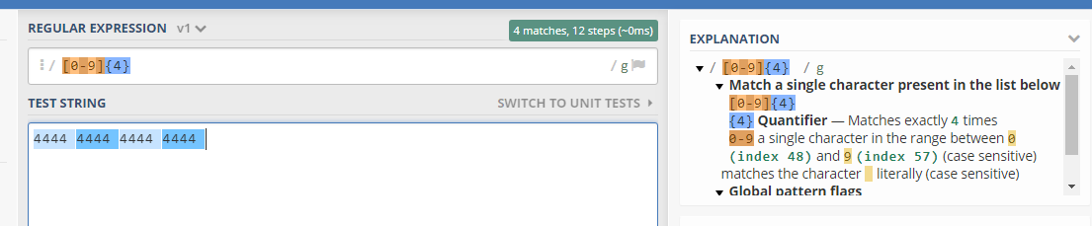

For alphabets also

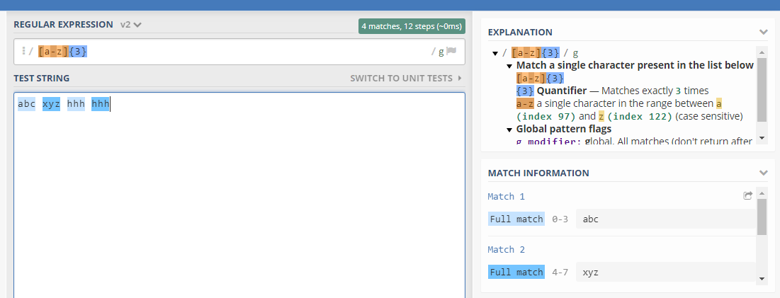

Minimum to maximum length specify :

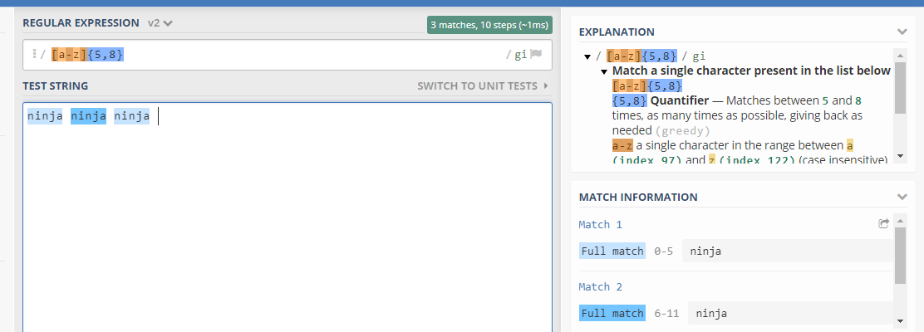

Word length from 5-8.

Least 5 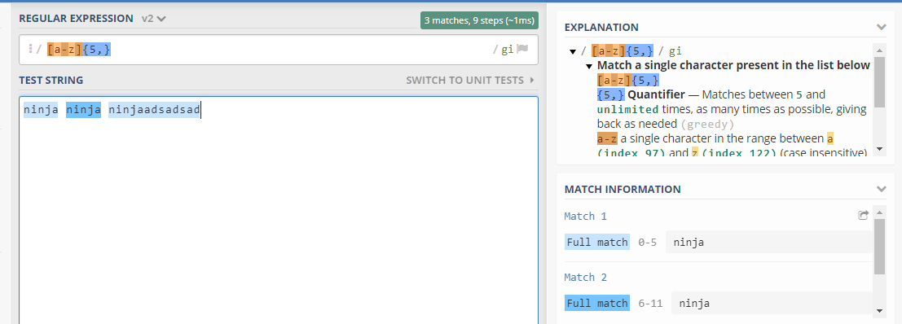

**Meta chracters :**

Predefined syntax used for matching

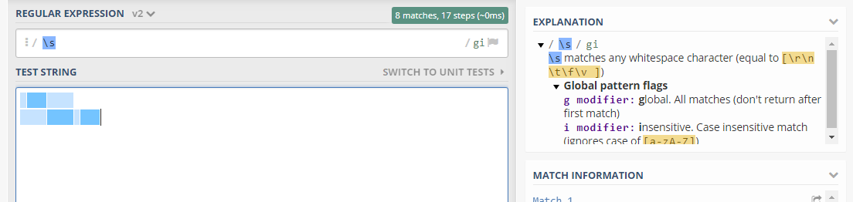

\s matches space and tab

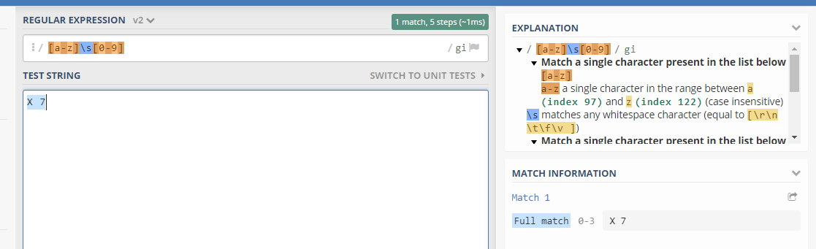

Special Characters :

?

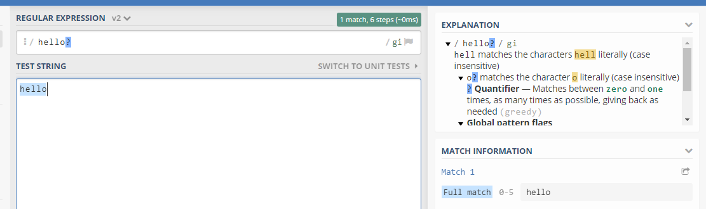

? means last character is optional may or may not exist

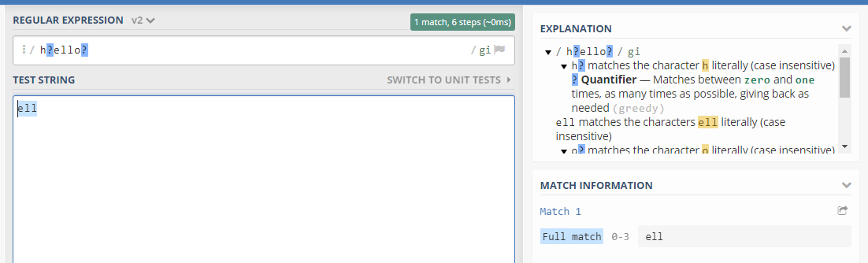

Dot (.)

Means it can be anything like @@$#$@%

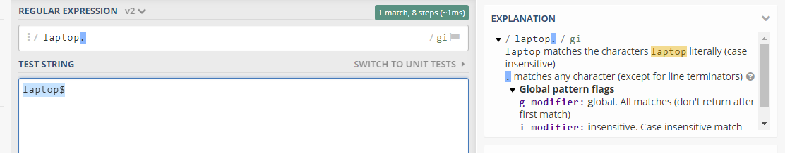

+ 1 or more times

* means 0 or more times

**Patterns :**

To pickup only first word.

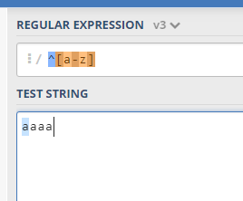

Length 5

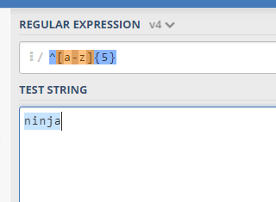

For end of field

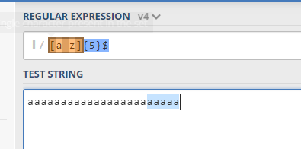

Alternative characters ( | ) :

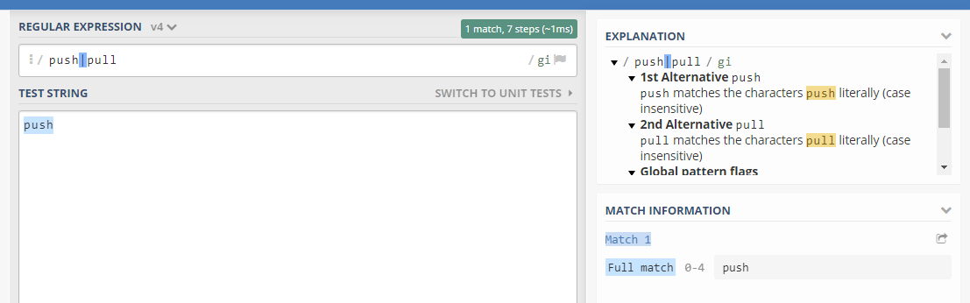

Either matches left or right one

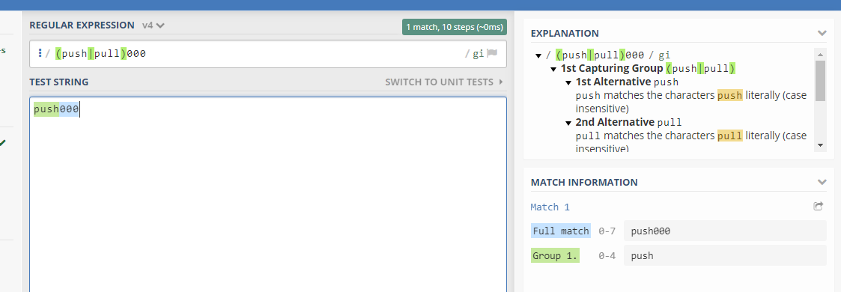

**Form :**

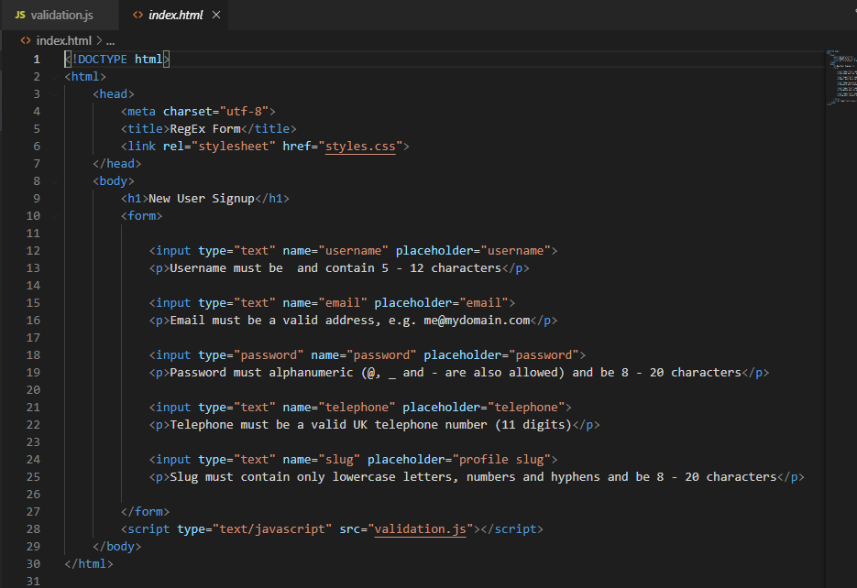

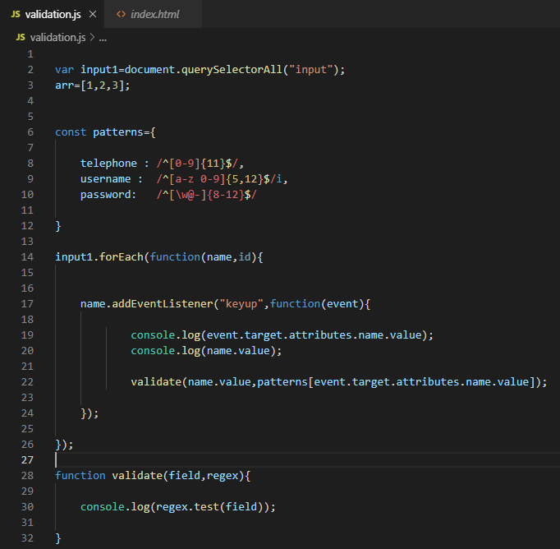

**Email :**

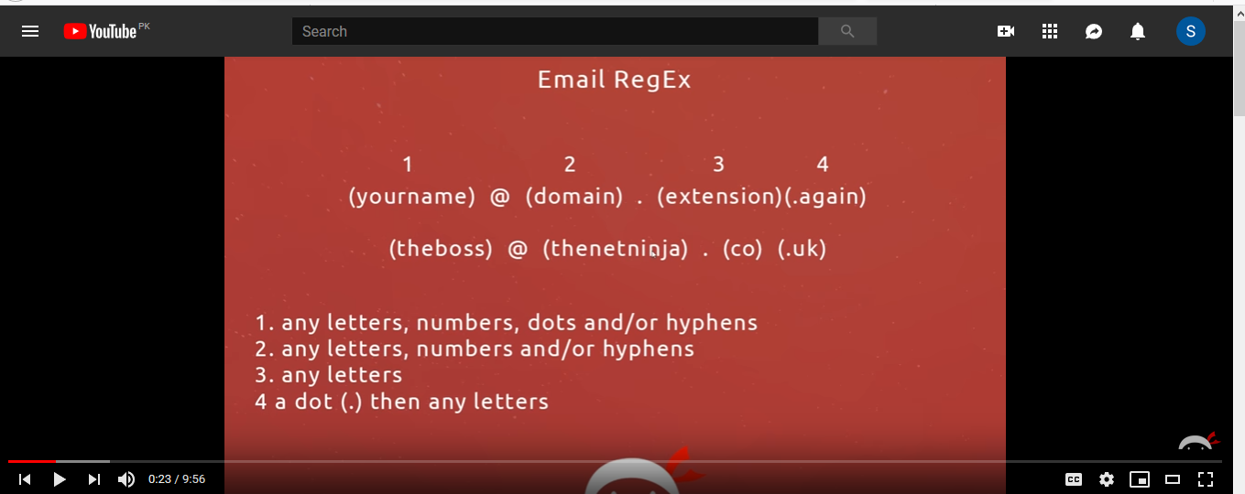

email : /^([a-z 0-9 \.-]+)@([a-z 0-9 -]+)\.([a-z]{2,6})(\.[a-z]{2,6})?$/